1. selection sort

CODE:

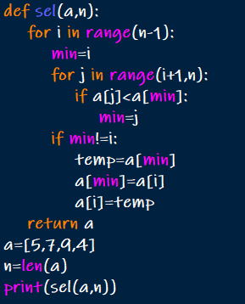

OUTPUT:



1. insertion sort

CODE:

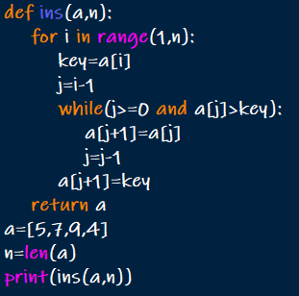

OUTPUT:



1. bubble sort

CODE:

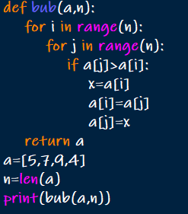

OUTPUT:



1. sequential search

CODE:

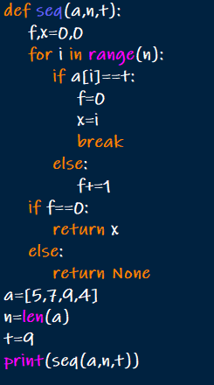

OUTPUT:



1. Brute force string matching

CODE:

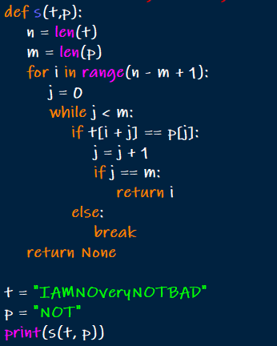

OUTPUT:



1. Closest pair

CODE:

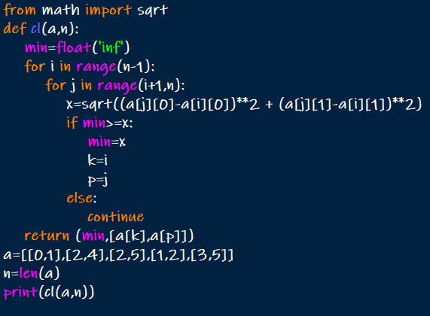

OUTPUT:



1. convex hull

CODE:

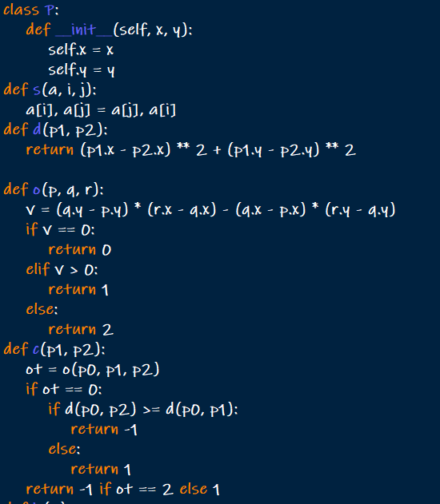

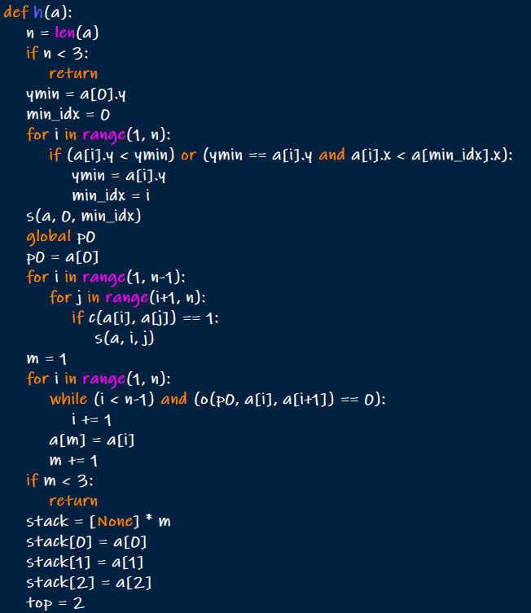

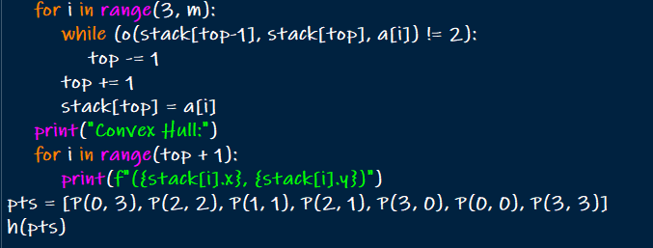

OUTPUT:

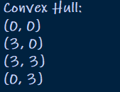

1. exhaustive search

CODE:

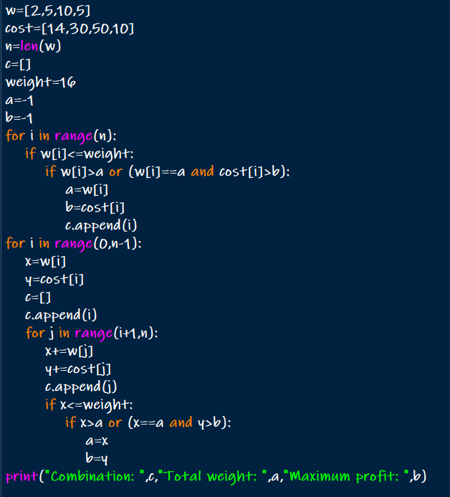

OUTPUT:

